Limit Onboarding for MBAM secondary VTD

[[FICCRISK-32258] Limit Onboarding for MBAM secondary VTD - Horizon/Jira2](https://jira2.horizon.bankofamerica.com/browse/FICCRISK-32258)

Scenario: Breach and No breach alerts for new Limit code for MBAM SECONDARY VTD should be generated successfully.

Given:  
Exposures in brisk for : MBAM SECONDARY

Creation of new Limit code in LMS

When:  
Run the respective VTD CFTC breach calc job in uat

Then:  
1. Breach and No Breach email must be generated successfully .  
2. Brisk report and exposures in email should match  
3. workflow should work successfully  
4. End of day reports , control reports, monthly reports should work successfully

Creation/Validation of new Limit code created in LMS and exposure numbers in brisk reports with measure name and filter provided by LOB. Follow up with LOB for the measure details and create a brisk report

**Sandra – LMS in UAT**

Volcker Business Area Volcker Trading Desk Limit Code Limit Name Limit Value Currency Status Maturity Name Product Type Risk Factor Name Significant Rating Shift Name Measure Measure Unit entity_id entity_name

MUNICIPAL BANKING AND MARKETS MBAM SECONDARY INTRA_FICC_237 INTRA_FICC_MUNI SECONDARY_USD_CS01+1bp 2000000.000 USD Active <None> <None> Credit Spread -1 CS01 b.p. 8009245 MUNICIPAL BANKING AND MARKETS





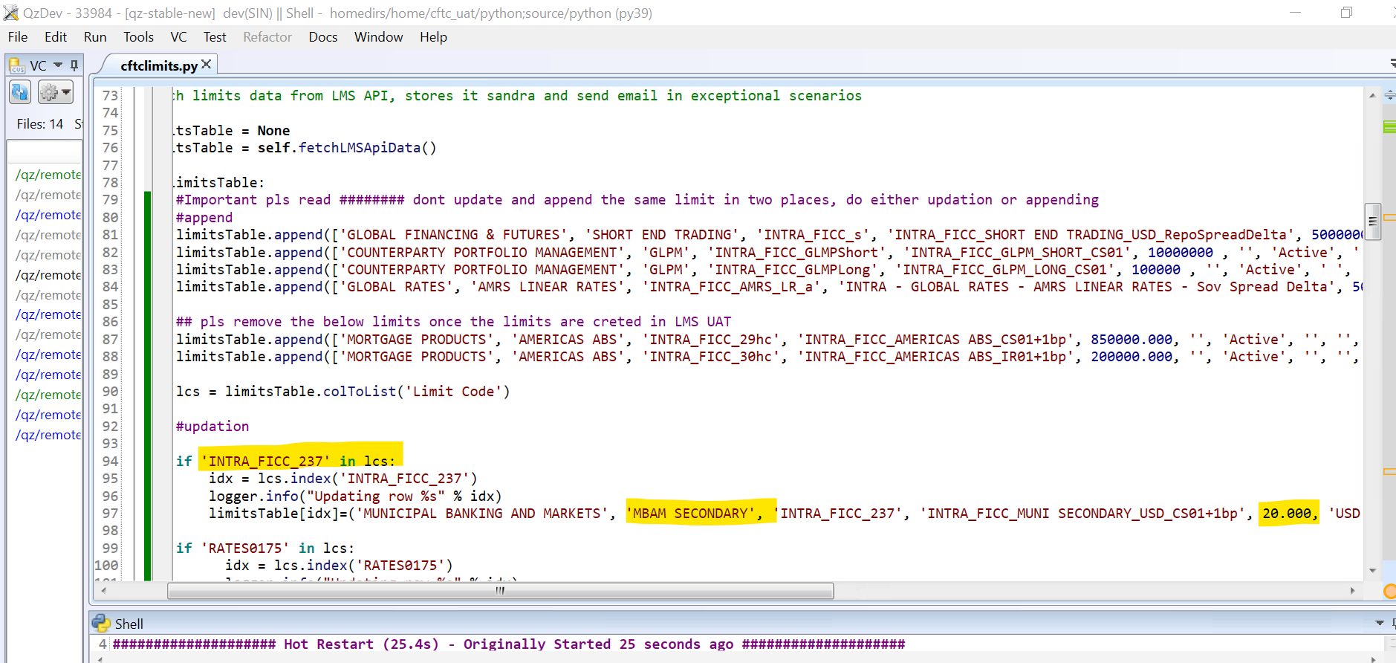

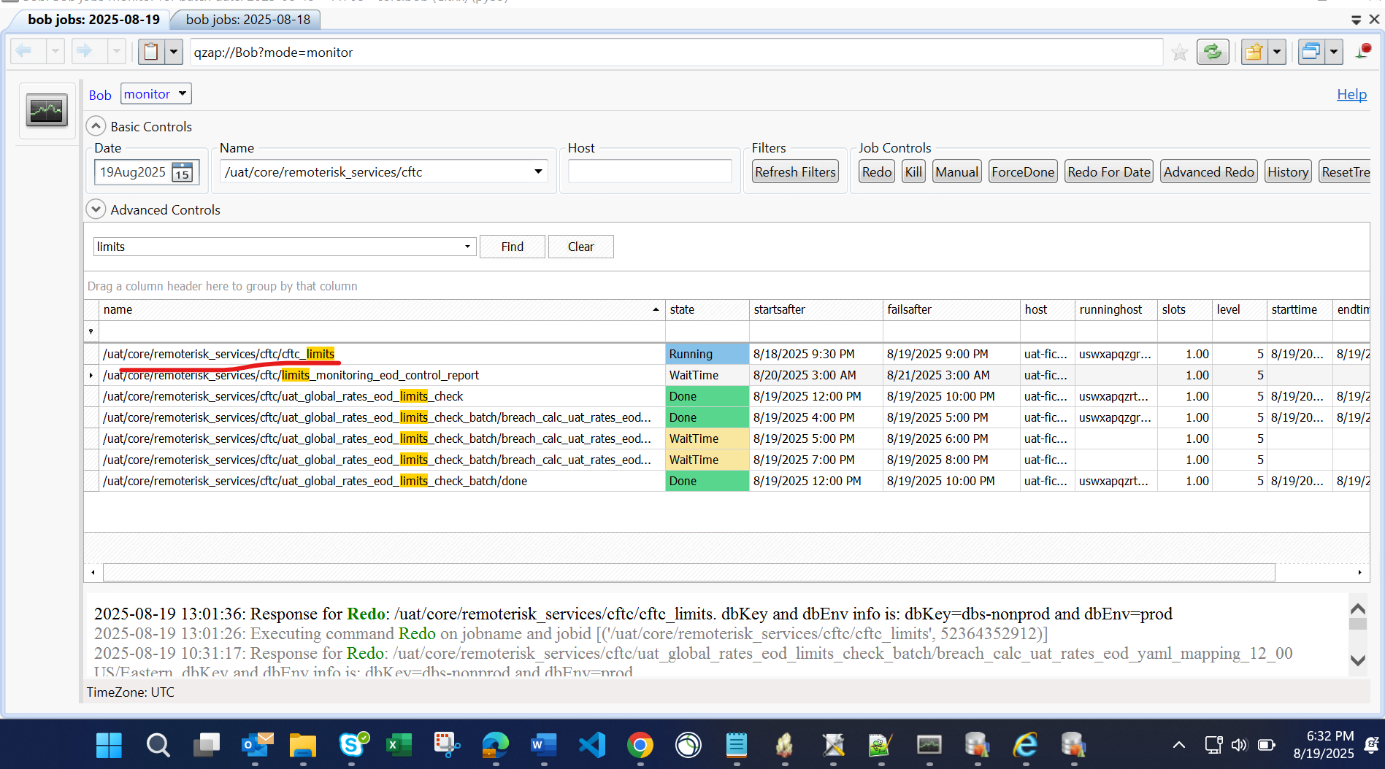

Limit changes reflecting in Comparison Report –

